Austin Beller
Applied Data Science Program
Syracuse University
ambeller@syr.edu

Data Science Portfolio

SUID: 751808362 Github: https://github.com/tue50771/Portfolio-Syracuse
Contents:
Brief Introduction: ……………………………………1
Project 1: How to Make a Database? ...........1
Project 2: Can we make a better database? .2
Project 3: Life expectancy how absurd is it? .4
Project 4: Neural Nets? ................................5
Project 5: Market Basket what is inside? ......5
Conclusion:………………………………………………….7

Brief Introduction:
The following is a complete coverage of all of my coursework here at Syracuse University and a summary of all I have learned over the past year and a half. I have picked a total of five projects from my studies here all of which were great projects with excellent groups. I have enjoyed my stay here at Syracuse University and look forward to the future ahead.
I believe that the following projects and coursework demonstrate and complete the following skills and goals of the program.
1. Describe a broad overview of the major practice areas in data science.
2. Collect and organize data.
3. Identify patterns in data via visualization, statistical analysis, and data mining.
4. Develop alternative strategies based on the data.
5. Develop a plan of action to implement the business decisions derived from the analyses.
6. Demonstrate communication skills regarding data and its analysis for managers, IT professionals, programmers, statisticians, and other relevant professionals in their organization.
7. Synthesize the ethical dimensions of data science practice (e.g., privacy).
Project 1: How to Make a Database?
The first project we will be covering is the very first project I ever undertook with no previous exposure or experience with databases and SQL. I was going to create a database to store tuition and salaries with job titles and also to accurately calculate the amount of time it will take to pay back. These numbers would be compared across the country state by state. This was a large task to undertake but I thought I was up to the challenge.
The first task was to develop a data dictionary of all of the different variables that would be used as well as the properties that we each would encompass (Beller “IST659” 2019). This required an understanding of what kind of data we would be analyzing as well as best practice for storage and organization of the different variables. This is generally the first step before even beginning the process of data collection and is one of the most important since it will be the template that we build upon (Beller “IST659” 2019).
The logical model and the entity diagram were the next task in organizing and building from the original idea that we came up with (Beller “IST659” 2019). This gave us an understanding of how the data was connected to each table and how each table would be built upon the other. Understanding these relationships is crucial if you are building a database so that when you are calling different operations in SQL such as joins, will create less errors when building from the warehouse you are producing or working from (Beller “IST659” 2019).
The final aspect was to build the database using the model we had developed using SQL (Beller “IST659” 2019). We also wrote the proper SQL code which would produce different values based upon the region or country you resided. This demonstrates an ability to collect and organize data as well as an ability to make decision based upon statistical analysis. The use of exporting this to a GUI (graphic user interface) allows stakeholders to make the appropriate decisions based upon the information given (Beller “IST659” 2019).
Project 2: Can we make a better database?
This next project was from Dr. Blocks IST 722 data warehousing course which involved building a fully deployable data warehouse (Beller “IST722” 2020). This was a group project that involved other classmates so we will only cover relevant work completed. The objective was to build a data warehouse based on a model provided using the Kimbal methods (Kimbal et. al 2008).
(Beller “IST722” 2020)
We created functional requirements for the vendor listed above. Which was vital in understanding the purpose of the database as well as the various business rules that would be developed from the outset. The bottom graph shows the flow once the database was appropriately created and the SSIS was functional.
(Beller “IST722” 2020)
What this demonstrates is ability to develop a plan of action to implement business decisions derived from the analysis of the database. This visuals above demonstrate a easy to read format that allows clear and concise communication throughout the organization.

Project 3: Life expectancy how absurd is it?
This project was also a group project which involved the importing of data from the Community Health Status Indicators (CHSI) to Combat Obesity, Heart Disease, and Cancer. Our objective was to compare different variables to the average life span of the United States across borders. The tool of choice used to examine this dataset was R using R studio and R commander. In images below show our exploration into the data specifically the poverty was the original variable of choice (Beller “IST 687” 2019).

(Beller “IST 687” 2019)
However, as we explored the data more, we found that poverty had very little to do with longer life expectancy. This led us to concluded other more definitive variables such as lack of exercise, smoking and obesity (Beller “IST 687” 2019).
What this demonstrates is an ability to develop alternative strategies from data (Beller “IST 687” 2019). Here there are multiple variables and any one could lead down a different path. In this case our initial inquiry did no yield any results which resulted in further analysis and an alternative strategy (Beller “IST 687” 2019).
Project 4: Neural Nets?
In the course IST 707 which was taught by Dr. Ying Lin we learned about data mining and various other statistical measure to be used in R (Beller “IST 707” 2019). These techniques included things such as Bayesian analysis, decision trees, association rules mining, k-nearest neighbor and summary statistics. These methods are invaluable as well as the ability to know which methods would be best to apply to each. In the project we explored such a topic using Digit Recognition Kaggle dataset (Beller “IST 707” 2019).
In order to successfully develop a model to examine the difference between KNN and SVM models we had to successfully import as well as clean the data. This was done In R using various methods. In the picture below is a sample of code which was used to clean the data sets retrieved from Kaggle. This project allowed us to demonstrate how to appropriately collect and organize the data.
sum(duplicated(testset)) # no duplicate rows
0
sum(duplicated(trainset)) # no duplicate rows
0
sum(sapply(testset, function(x) sum(is.na(x)))) # There are no missing values
0
sum(sapply(testset, function(x) sum(is.na(x))))# There are no missing values
0

Project 5: Market Basket what is inside?
This is the final project we will be presenting here we used another Kaggle competition (Beller “IST652” 2020). In this case we used the Instacart online grocery analysis to create an association rules mining with visualizations to explain and easily disseminate the appropriate information to stakeholders (Beller “IST652” 2020).
This project was different from the others in that it used python a different programing language from R (Beller “IST652” 2020). The visualizations were produced in python using matlab and the calculations and data frames used were pandas and NumPy. We were able to display the graphs as though they were in R by selecting the style ggplot (Beller “IST652” 2020).
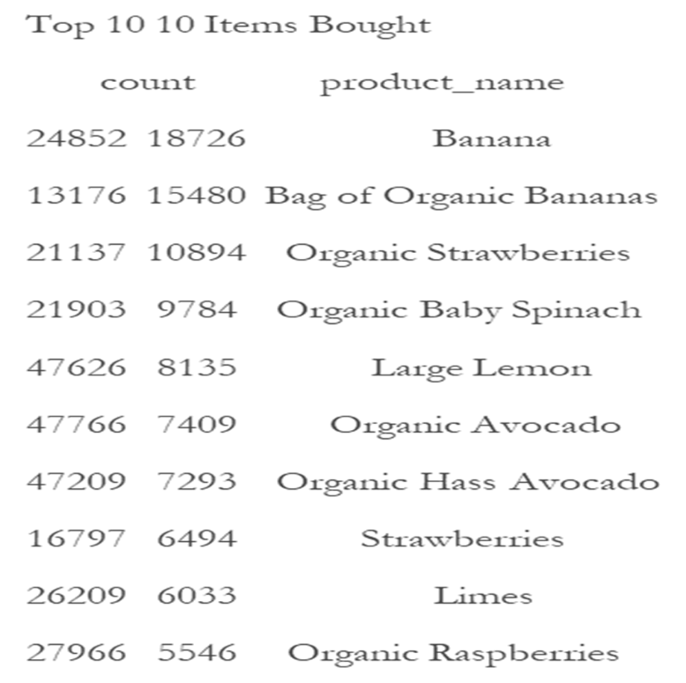

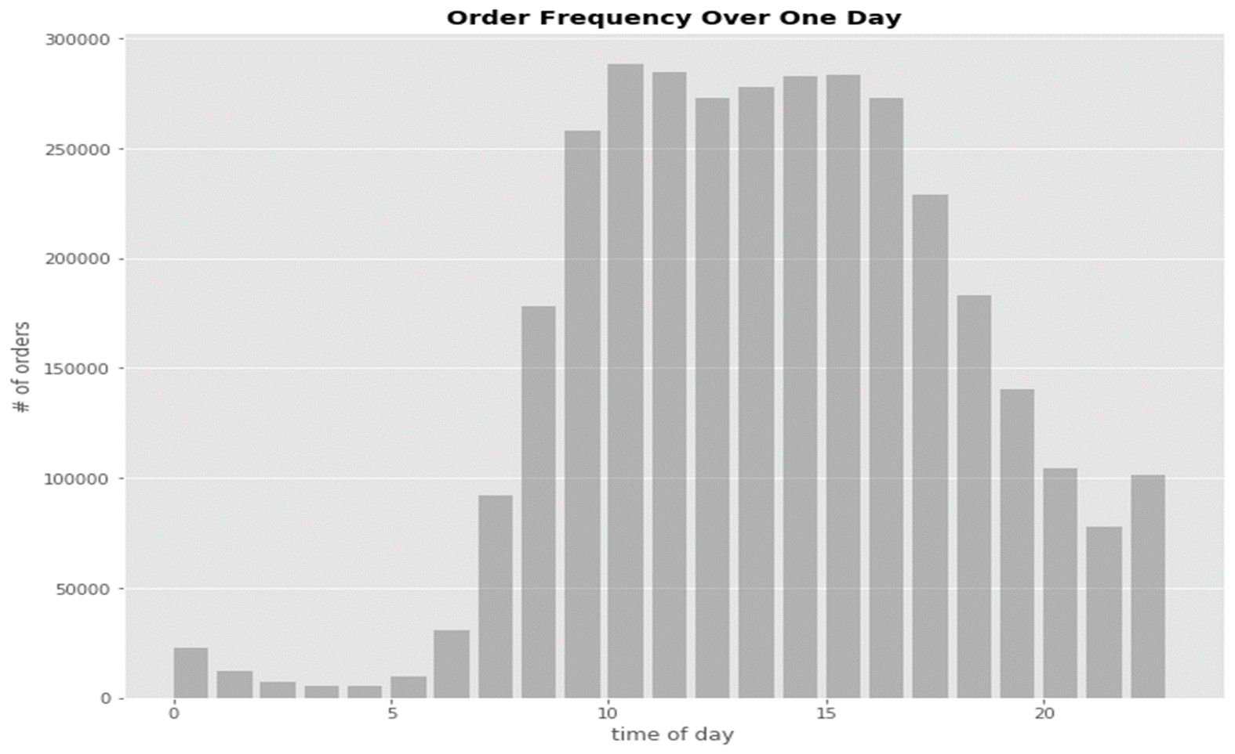
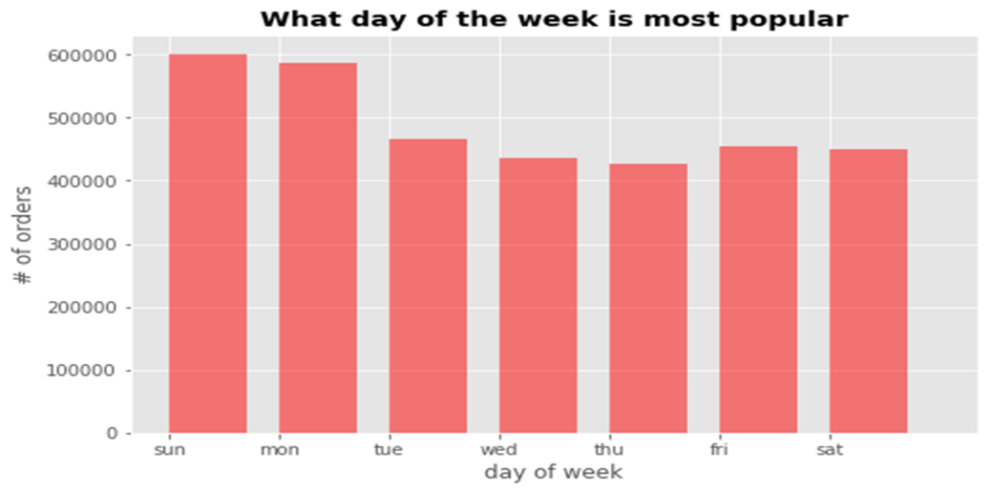
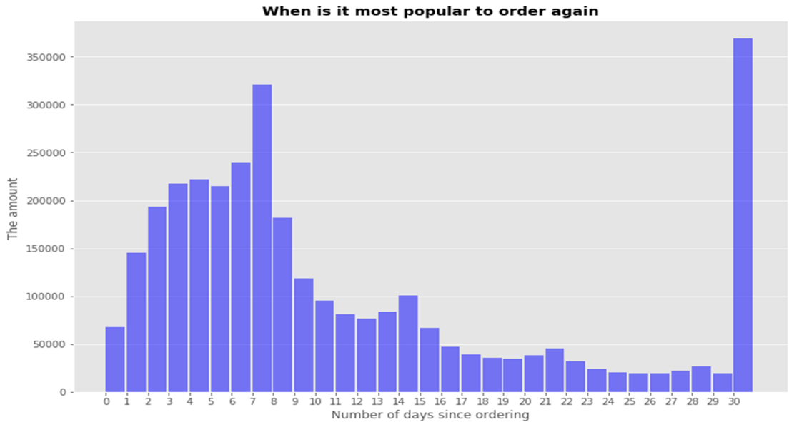
The project in this case displayed the ability to visually identify consumer patterns using visualization and statistical methods (Beller “IST652” 2020). These would help the stakeholders develop action plans and allow for the implementation of new business strategies based on the analysis. The possible ethical impact of collecting consumer data was considered before using this dataset (Beller “IST652” 2020).
Conclusion:
The following projects demonstrate and meet the requirements of learning objectives of the program as well as describe a broad overview of major practices in the area of data science (Beller “IST659, IST722, IST687, IST707, IST652,”). We properly demonstrate how to collect and organize date in a reasonable fashion and demonstrate communication skills giving a straightforward and easy to understand way of communicating the data (Beller “IST 652, IST 707”). We also showed an ability to identify patterns and develop alternative strategies or action plans based on the analyses (Beller “IST659, IST722, IST687”). During all of our courses we had a variety discussion of the use of data and how to ethically collect and use data (Beller “IST659, IST722, IST687, IST707, IST652,”).
This has been an enjoyable time at Syracuse in the applied data science program. I have learned a lot of material from how to use python and R. To how to construct a database from just business functions and objectives. Without having any experience previously the professors and classes made it incredibly clear to learn and understand the material.

